Exp No: 8a Simulation of EMI Sources and Interference Analysis using MATLAB

Objective 1: Generate and Simulate EMI Sources Using MATLAB

Program:
clc;
clear;
close all;
fs=10000;
t=0:1/fs:0.01;
signal=sin(2*pi*1000*t);
emi=0.5*sin(2*pi*2500*t);
received=signal+emi;
figure;
subplot(3,1,1);
plot(t,signal);
title('Desired Signal');
subplot(3,1,2);
plot(t,emi);
title('EMI Signal');
subplot(3,1,3);
plot(t,received);
title('Received Signal with EMI');

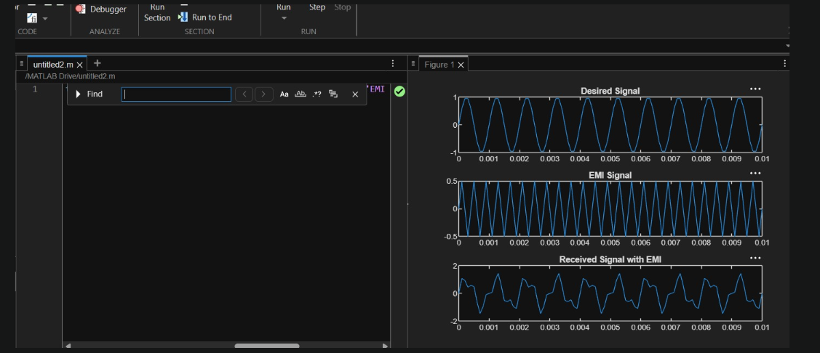

Objective 2: Analyze EMI Effects in Time and Frequency Domain

N=length(received);
f=(-N/2:N/2-1)*(fs/N);
Spectrum=abs(fftshift(fft(received)));
figure;
plot(f,Spectrum);
xlabel('Frequency (Hz)');
ylabel('Magnitude');
title('Frequency Spectrum');
grid on;
Op:

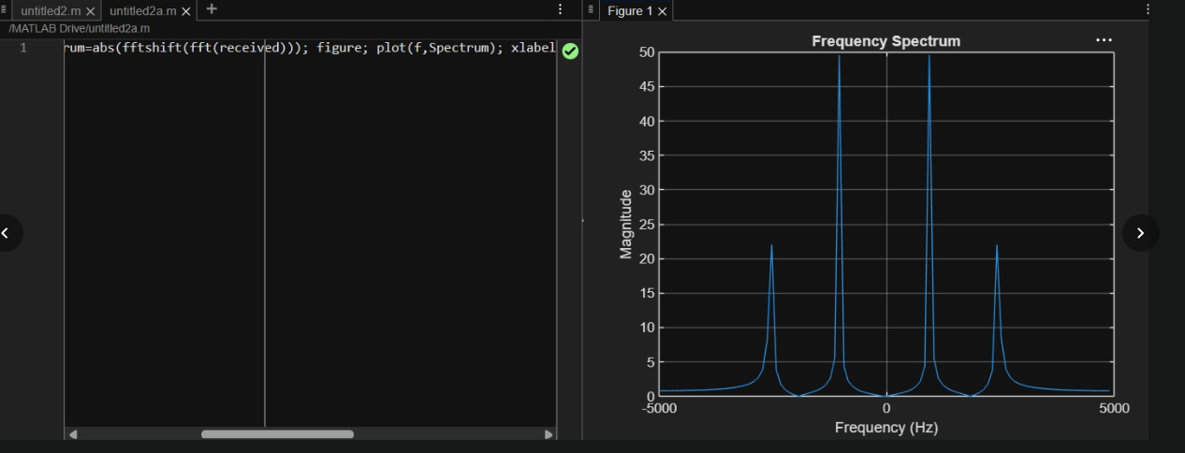

Exp No:8b Shielding Effectiveness and EMC Compliance Analysis using MATLAB

Code:

clc;
clear;
close all;
%% Objective 1 : Shielding Effectiveness Simulation
f = logspace(6,9,1000); % 1 MHz to 1 GHz
mu0 = 4*pi*1e-7;
sigma = 5.8e7; % Copper conductivity
t = 1e-3; % Shield thickness
omega = 2*pi*f;
delta = sqrt(2./(omega*mu0*sigma));
A = 8.686*(t./delta); % Absorption Loss (dB)
%% Objective 2 : Reflection and Multiple Reflection Loss
sigma_r = 1;
mu_r = 1;
R = 168 - 10*log10((sigma_r)./(mu_r*f));
B = 5; % Approximate Multiple Reflection Loss
SE = R + A + B;
%% Objective 3 : EMC Compliance Analysis
EMC_Limit = 50*ones(size(f));
Measured_Emission = ...
40 + 5*sin(2*pi*log10(f)/3);
Margin = EMC_Limit - Measured_Emission;
Compliance = Margin > 0;
%% Display Results
fprintf('\nSHIELDING EFFECTIVENESS RESULTS\n');
fprintf('---------------------------------\n');
fprintf('Maximum SE = %.2f dB\n',max(SE));
fprintf('Minimum SE = %.2f dB\n',min(SE));
if all(Compliance)
fprintf('System is EMC COMPLIANT\n');
else
fprintf('System is NOT EMC COMPLIANT\n');
end
%% Plot Results
figure('Name',...
'Shielding Effectiveness and EMC Compliance',...
'NumberTitle','off');
subplot(2,2,1)
semilogx(f,A,'LineWidth',2)
grid on
title('Absorption Loss')
xlabel('Frequency (Hz)')
ylabel('Loss (dB)')
subplot(2,2,2)
semilogx(f,R,'LineWidth',2)
grid on
title('Reflection Loss')
xlabel('Frequency (Hz)')
ylabel('Loss (dB)')
subplot(2,2,3)
semilogx(f,SE,'LineWidth',2)
grid on
title('Shielding Effectiveness')
xlabel('Frequency (Hz)')
ylabel('SE (dB)')
subplot(2,2,4)
semilogx(f,Measured_Emission,...
'LineWidth',2)
hold on
semilogx(f,EMC_Limit,...
'r--','LineWidth',2)
grid on
legend('Measured EMI',...
'EMC Limit')
title('EMC Compliance Analysis')
xlabel('Frequency (Hz)')
ylabel('Emission Level (dBμV/m)')

